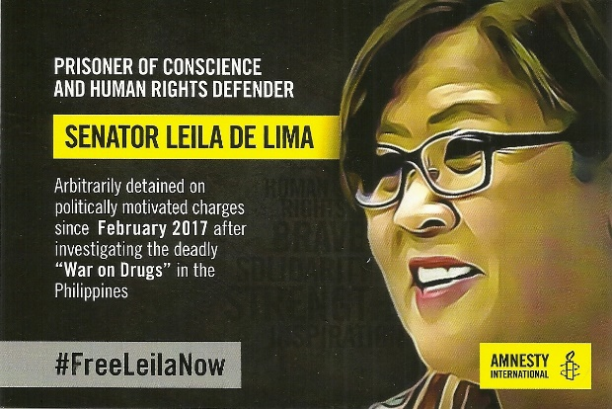
OFFICE OF SENATOR LEILA M. DE LIMA
Room 502, 5th Floor, GSIS Bldg., Financial Center
Pasay City, Philippines 1308
senleilamdelima@gmail.co

Hello Senator De Lima,

We of Amnesty International Group 37, St. Paul and Minneapolis, Minnesota, and human rights activists across America are most pleased to know that despite your difficult circumstances you are continuing to advocate for human rights in the Philippine Senate. We continue to support your efforts

Amnesty International considers you to be a Prisoner of Conscience. It and other numerous human rights defenders are very concerned at all times about the state of human rights in the Philippines and have pledged to keep advocating for your immediate and unconditional release. We also advocate for US policy that will let the current administration in the Philippines know that the people of the US are very concerned about the deterioration of human rights and freedom of speech and association in the Philippines. We do not want our government to contribute in any way to the continuation of such deadly policies of the Philippine Government and request that our representatives in Washington speak out strongly against human rights violations and advocate for your immediate release.

We hope your spirits are buoyed knowing that so many people around the world are concerned about your well-being and appreciate your admirable efforts for peace and freedom.

Season’s Greetings & Best Wishes for Your Personal Relief and Freedom (now!),

